Chapter 5, Solution 6.
+
-
Av_{d}
-
+
v_{i}
I
R_{in}
R₀
+
v_{o}
-

-

v_{d}

+

(R₀ + R_{i})R + v_{i} + Av_{d} = 0

But v_{d} = R_{i}I,

v_{i} + (R₀ + R_{i} + R_{i}A)I = 0

I = 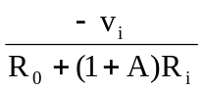 (1)

-Av_{d} - R₀I + v_{o} = 0

v_{o} = Av_{d} + R₀I = (R₀ + R_{i}A)I
Substituting for I in (1),

v₀ = 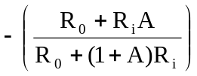v_{i}
= 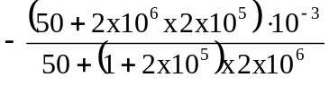
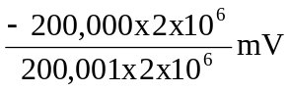
v₀ = -0.999995 mV

